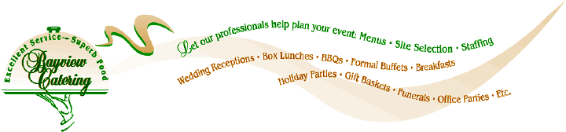

Date: October 23, 2025

To: Kailyn Nygren
NYCO Construction

RE: Holiday party
7651 Old Hwy 99, Tumwater, WA 98501
Saturday, December 13th, 5:30 pm
70 guests estimated

Dear Kailyn:

Here is the proposal based on our conversation and my understanding of your catering needs.

QUANTITY DESCRIPTION UNIT PRICE EXTENDED PRICE
70 serv Artichoke/parmesan dip 3.95 ea 276.50
70 serv Smoked salmon pate 4.65 ea 325.50
1 lg Bruschetta tray 99.95 ea 99.95
70 ea Dinner buffet 36.95 ea 2586.50
Includes prime rib with au jus and creamy horseradish sauce, baked salmon with lemon dill sauce, herb roasted red potatoes, Caesar salad, pasta salad, rustic breads with butter
Delivery 50.00
Service fee 250.00
Business operation fee 358.85
Sales tax 9.7% 382.89
Gratuity 590.00
Total 4920.19

Page two

QUANTITY DESCRIPTION UNIT PRICE EXTENDED PRICE
70 serv Artichoke/parmesan dip 3.95 ea 276.50
70 serv Smoked salmon pate 4.65 ea 325.50
1 lg Bruschetta tray 99.95 ea 99.95
70 ea Dinner buffet 24.95 ea 1746.50
Includes beef sirloin with creamy horseradish sauce, baked salmon with lemon dill sauce, herb roasted red potatoes, Caesar salad, pasta salad, rustic breads with butter
Delivery 50.00
Service fee 250.00
Business operation fee 274.85
Sales tax 9.7% 293.26
Gratuity 440.00
Total 3756.56

Page three

Terms and Conditions

- Bayview will provide all necessary serving utensils and equipment and disposable place settings.

- Customer will provide tables, desserts and beverages. Customer or venue will set up the tables and chairs. We need (2) 6’ tables for food service.

- Service fee: We will deliver, set up, carve the entrée, replenish, pick up plates and debris, pack up left overs and remove our equipment. I have estimated 2 catering staff for 5 hours.

- Guest count. One week before the event we will need your final guest count. We will adjust according to the person charge listed above.

- Deposit and acceptance. If this proposal is acceptable, please sign and return along with you deposit of $500 to reserve the date and prices quoted above. Your deposit is non-refundable and will be applied to the balance.

- Business Operations Charge: The business operations charge is industry standard. It’s to cover costs to get equipment and food staged, packed, transported (including vans and gas), returned and cleaned. It also includes administrative efforts to pull all the details of your event together. It’s spread throughout the business to cover costs that you don’t see.

- Payment: You may pay by check or any credit card. We require final payment one week before the event. After this date the entire amount is non-refundable.

- Expiration: This proposal expires on 10/30/2025. You may accept it after its expiration subject to our availability and subject to current prices at the time of acceptance.

__________________________________ Kelly Young 10/23/2025
Kailyn Nygren/ Date Kelly Young/ Bayview Catering/ Date

